A huge thank you to Mrs Maura Howard, our lovely Rainbow Nursery friend, for her generous donation of plants for our planters.

She even thought of Rainbow colours!

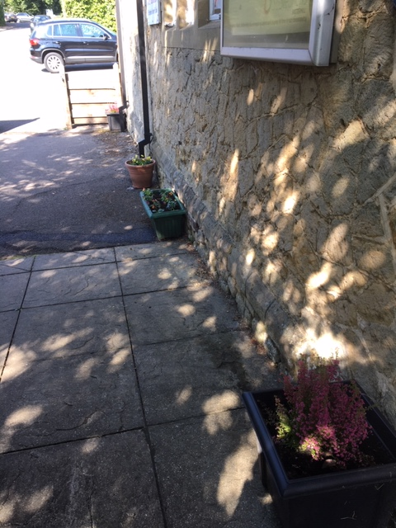
Front entrance
Drop off door
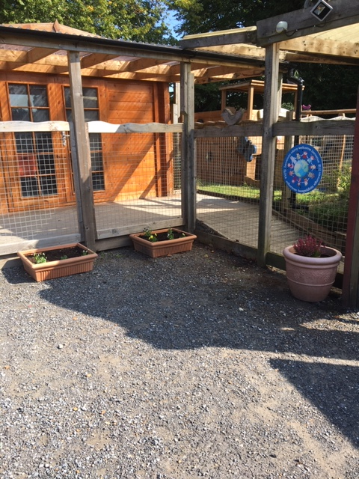

Gate – pick up

